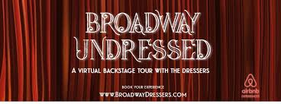
Bid for an interactive virtual experience, featuring top notched Wardrobe Professionals that gives you a peek into the wings of a Broadway Production.

Broadway Undressed was developed by Jessica Dermody, a Broadway Vet of over 20 years who has worked on countless Broadway shows. She also has extensive background in producing, which makes her insight to the backstage world especially educational.

Every session is unique based on the patrons joining us as well as the Broadway personnel participating. We all bring our own life experience and energy into the space- just like live Theatre! Some frequent topics include: Wardrobe malfunctions, emergency understudy action, traditions, B-way lore, and superstitions encountered by wardrobe.

